WEATHER REPORT MONITORING SYTEM USING IOT

Introduction:

The Role of IoT in Weather Reporting Systems
Traditional weather monitoring systems are getting outdated. They’re often prone to errors and inaccurate predictions — and these factors can damage your business. But with IoT in place, these systems transform dramatically. Here’s how.
- Traditional weather reporting methods, while informative, often suffer from delays in data collection and transfer. IoT, in turn, gathers data from sensors in real time.
- IoT takes forecasting to the next level when combined with internet-connected weather stations. It can predict the weather accurately and quickly for different geographic locations.
- IoT-based weather monitoring systems seamlessly integrate data from a multitude of sources. Weather sensors, satellite imagery, weather stations, drones, and even personal devices are just some examples.
- The Internet of Things brings precision to weather insights. Businesses can collect data from specific places, e.g., by improving crop watering based on soil moisture or changing flight paths to avoid turbulence.

Benefits of Weather Reporting System Using IoT
With the Internet of Things, weather monitoring systems have stepped up their game, becoming more accurate, consistent, and quicker in operation. Now, that sounds great, but what does this tech actually offer businesses? Here are the main benefits:
- Real-time data collection. Thanks to IoT devices and sensors, businesses get weather updates from all sorts of locations right when they need them.
- Higher accuracy. A weather monitoring system using IoT gathers data from numerous sources, providing a detailed picture of what’s happening with the weather.
- Wider coverage. Traditional weather monitoring systems usually check conditions at just a few weather stations, leaving out other areas. When IoT technology steps in, businesses can cover more places, even the most distant ones.
- Predictive analytics. IoT-powered weather reporting systems use historical data and current trends to tell businesses what’s coming. That’s how companies can adjust their operations before any weather-related challenges appear.
- Reduced response time. Every second counts when the industry is about making fast decisions — aerospace or emergency services. That’s where IoT weather monitoring comes in as a solution, offering real-time insights for rapid response times.
- Cost-effectiveness. A weather reporting system using IoT allows companies to optimize resource usage and reduce waste. For example, agriculture businesses can leverage weather forecasts to adjust their irrigation and crop protection measures.
- Increased safety. Industries prone to weather-related risks, like construction or transportation, enjoy the advantages of IoT-based automatic weather stations. These businesses can plan their activities more safely with a minimum of accidents and disruptions.
- 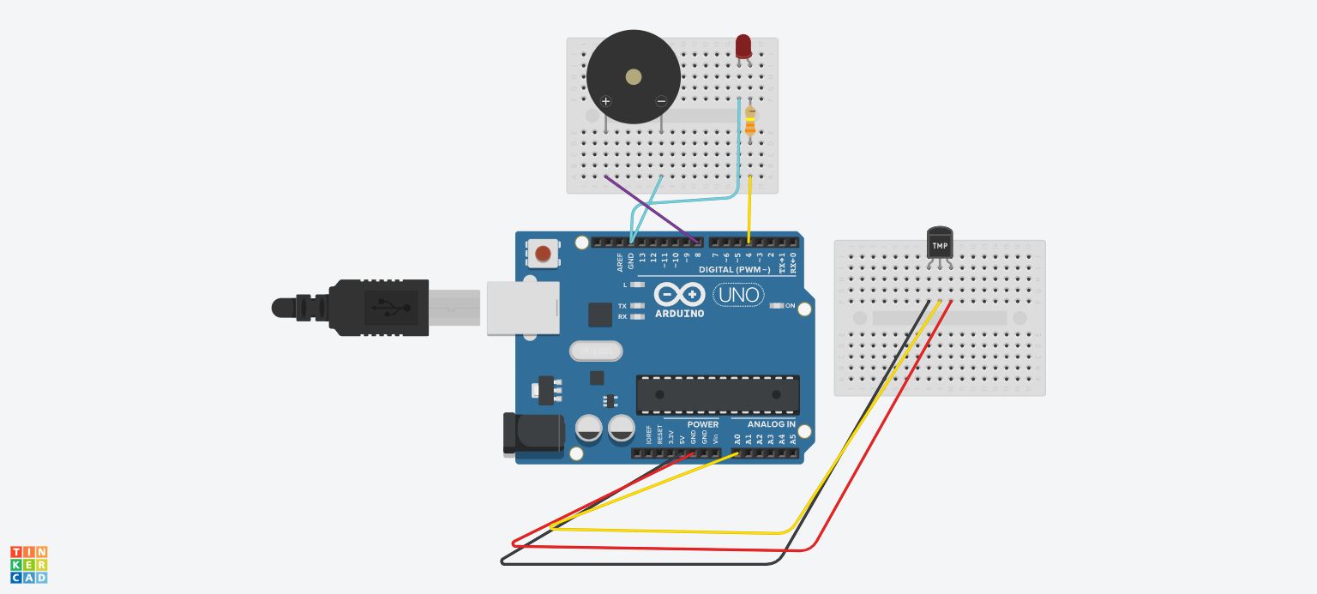
FIG: WEATHER REPORT MONITORINNG SYSTEM USING IOT

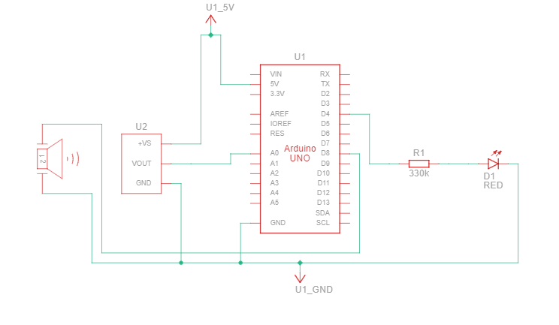

FIG:CIRCUIT DIAGRAM OF A WEATHER REPORT MONITORING SYSTEM

COMPONENTS USED IN THE PROJECT:

Name | Quantity | Component
U1 | 1 | Arduino Uno R3
U2 | 1 | Temperature Sensor [TMP36]
PIEZO1 | 1 | Piezo
D1 | 1 | Red LED
R1 | 1 | 330 kΩ Resistor

